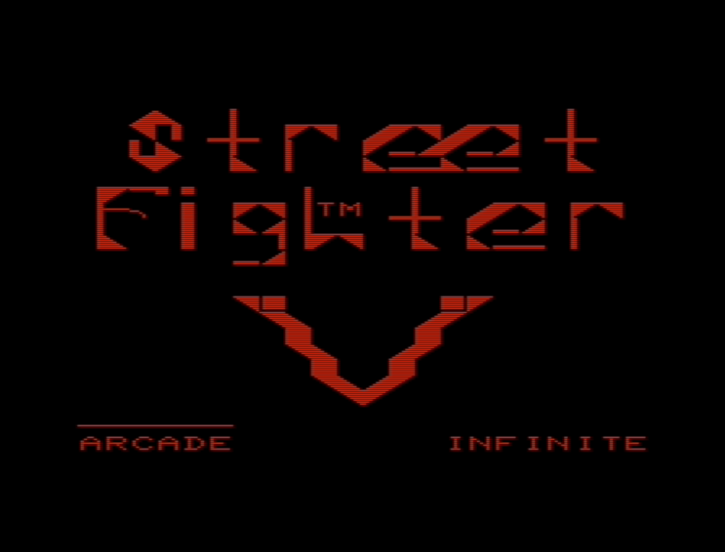

**Contents**

Getting Started ………………………… 2

Story ………………………………………… 3

Characters ……………………………….. 4

Controls …………………………………… 5

Rules of Combat ………………………. 6

Character Select Screen …………… 7

Game Screen …………………………… 8

Game Modes …………………………… 9

Credits …………………………………….. 10

**Credits**

Creators

Dabin Lamming

Christian Velasco

Chi Nguyen

Story and Character descriptions taken from the actual game manual which can be found here: <http://static.capcom.com/manuals/sfiv/SFIV_PS3_DMNL_EN.pdf>

Images used are self created and from actual gameplay

**Story**

The Tournament Begins Anew

Just as the excitement of the previous, now legendary tournament finally fades, word of anew world fighting tournament spreads like wildfire among martial artists across the globe, trailing a series of bizarre rumors along behind.

The mysterious disappearances of numerous famous fighters. A terrible threat in the form of a new, deadly secret weapon. The possible connection between S.I.N., the sponsor of the new tournament, and the supposedly destroyed Shadaloo.

New fighters also step up and make themselves known, almost as though responding to these troubling rumors.

A young man who searches for his lost past. A man who burns with the desire to defeat his greatest rival.

Before these newcomers stand those from the previous tournament, each bringing their own renewed determination

Some fight for those dear to them. Some fight to finally take their revenge. And some fight simply so that the entire world will chant their name.

A complex clash of human relationships and the truth of a terrible plot that lurks behind the championship.

This is the chaos that Ryu, who has been honing his skills with the simple goal of becoming the ultimate fighter, one beyond the constraints of mere mortality, now finds himself thrown into…

Amid pursuit and escape, friendship and betrayal, the curtain rises on a new stage of battle!

**Game Screen**

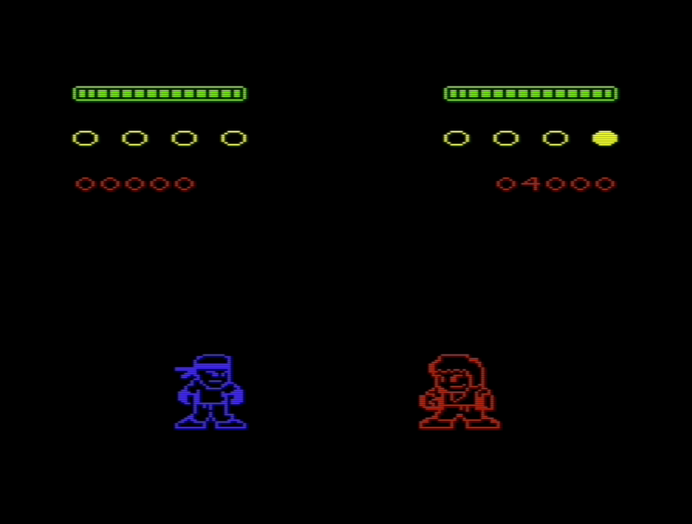

1

5

3

4

2

1 Character Health Bar

2 Round Win Counter

3 Player Score

4 Player 1

5 CPU / Player 2

**Game Modes**

Arcade Mode

In this mode, you select a character and face three matches against the same opponent. There are 3 levels of opponent difficulty, from quite easy to quite hard. If you are defeated along the way, the game is over. Win all three matches to be declared the champion.

Infinite Mode

In this mode, you battle with your opponent until you lose a match. The goal is to get the highest score possible.

**Getting Started**

Vic-20 System

To load the game, insert the SD card into the vic-20. On screen type in:

***StreetFighter.out load “*”, 8, 1***

Wait for the game to be loaded in. Then type:

***run***

Vic-20 Emulator

Change the memory settings in the emulator by going to ***Settings > Vic 20 Settings… > 3K (block 0)*** before loading in the game.

**Controls**

Character Selection Screen

|  |  |
| --- | --- |
| Button | Function |
| A | Move Cursor Left |
| D | Move Cursor Right |
| S | Select Character |

In-Game Screen

|  |  |
| --- | --- |
| Button | Function |
| A | Move Left |
| D | Move Right |
| S | Block |
|  | Punch |
|  | Kick |

**Rules of Combat**

Match Setup

Seven (7) round matches. The first fighter to win four (4) rounds is the winner.

Winning Rounds

Reduce your opponent’s health meter to 0 for a win by KO. Time your blocks and strikes to work against the opponent.

Scoring

Each match win is worth 2000 points but you lose 400 points for each round your opponent won.

**Character Select Screen**

1

1 Selection Marker

Move the cursor over the character you would like to select, press (W) to cycle through color choices, and hit the select button (S).

**Characters**

|  |  |  |
| --- | --- | --- |
| Ryu | | A lone-wolf street fighter who has further honed the techniques taught by his master Gouken through intensive daily training. Many fighters have been drawn to and inspired by his lifestyle and strength. Ryu now travels the world in order to become a “True Martial Artist”, but soon finds himself caught up in a plot to exploit his impressive powers. |
| Ken | Ken trained with Ryu, who quickly became his closest friend and greatest rival. Ken is the heir apparent to the largest conglomerate in the U.S., the Masters Family. Due to the new life now growing within his wife, Ken is hesitant to take Ryu up on his latest challenge, but Eliza herself persuades him to enter the tournament. | |
| Fang | An assassin and the sole survivor from the Nguuhao cartel, who uses poison to attack. After the Nguuhao falsely pledged their allegiance to Shadaloo, they attempted to murder Bison, who in returned slaughtered the entire cartel, except for their most skilled assassin, FANG, who now swears his unyielding loyalty to him upon knowing the extent of his powers. | |